Call for applications:

Social Media Copy – Instagram, Facebook and LinkedIn

Applications for the Commonwealth Startup Fellowship are now open! Starting in November 2025, the CSF is a six-month programme designed to fuel high-potential startups from across eligible Commonwealth countries and move them closer to commercial reality. If you’re a startup with early-stage traction and want to gain essential skills and build a global network, then apply now!

The Fellowship includes:

£35,000 Fellows Fund
Fully funded 2-week intensive bootcamp in Accra, Ghana
Online workshops and coaching
Build a global network of fellow entrepreneurs
Pitch to and meet investors from around the world

The application deadline is Monday 30th June. Make your application via the Imperial Enterprise Lab website!

Delivered in partnership with Imperial College London and the Commonwealth Scholarship Commission.

www.imperialenterpriselab.com/csf

Social Media Copy –

Applications for the Commonwealth Startup Fellowship are now open! The CSF is a six-month programme designed to fuel high-potential startups from eligible Commonwealth countries and move them closer to commercial reality. If you want to gain essential skills and build a global network, then apply now!

Delivered in partnership with Imperial College London and the Commonwealth Scholarship Commission.

www.imperialenterpriselab.com/csf

LinkedIn, X & Facebook

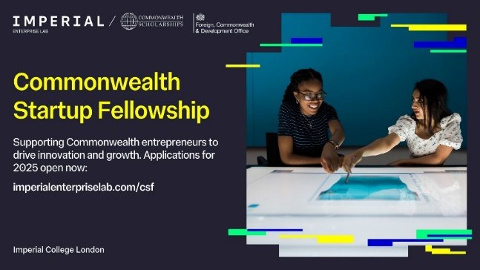

Instagram Stories

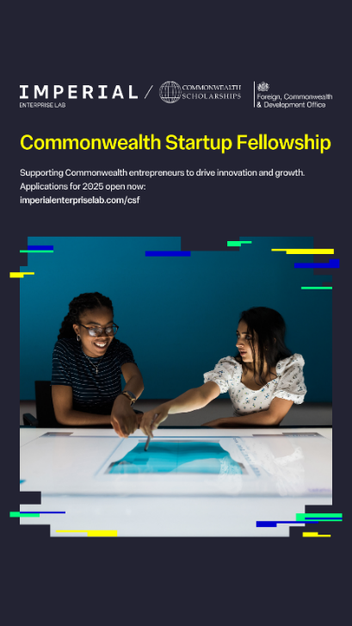

Instagram grid
