MSS

**TONGA MINISTRY OF EDUCATION**

Minimum Service Standards for Schools

TONGA EDUCA T ION SUPPORT PR OJECT (TE S P)

## Minimum Service Standards for Schools

 Ministry of Education

## Table of Contents

Acronyms

CHAPTER 1

Why MSS for Schools……………………………………………………………….1

What are Minimum Service Standards?............................................2

Commitment to Education……………………………………………………….4

Principles underpinning the MSS……………………………………..…….…4

What are standards?..........................................................................5

CHA P TER 2

Areas of the MSS……………………………………………………………….…...6

Teaching methods……………………………………………………………………7

Teaching and Management Capacity…………………………………………7

Learning Environment………………………………………………………………8

Student Achievement……………………………………………………………….8

Overall, School Performance…………………………………………………….9

Chapter 3

How will MSS work in Schools?.........................................................10

CHA P TER 4

The Minimum Service Standards……………………………………………….11

List of Curriculum Materials…………………………………………………..…19

Inspection Form for Secondary Schools…………………………………….22

T O N G A M I N I S T R Y O F E D U C A T I O N M I N I M U M S E R V I C E S T A N D A R D S

1

### Why Minimum Service Standards for Schools

*Vision for Education in Tonga- “That the people of Tonga will achieve excellence in education that is unique to this country and that Tonga will become a learning society”*

he development of Minimum Service Standards for Schools (MSS) has arisen as a result of a desire by the Government of Tonga to improve the quality of education within the country.

T

K E Y I S S U E S

 Limited readiness of school graduates for productive employment

Lower achievement

levels in literacy and numeracy of school graduates

Inequities to access

Tonga has made commendable achievements in achieving universal primary education. However, the Government of Tonga recognizes the need to improve the quality of education it is providing so that it and the students of Tonga are able to meet the challenges of being a member of the global community. Recent reviews indicate a number of concerns and issues in relation to education in Tonga. Most notably is the emerging evidence of the quality of education, particularly in the areas of readiness of school graduates for productive employment in a market economy and the levels of

basic literacy and numeracy of young graduates of Tonga’s education system.

Another issue of concern is the apparent inequities in education at the secondary level, due primarily to the varied quality of education provided by government and non-government schools, as well as the restricted access to government run secondary schools. The issue of inequities in access also applies to some primary schools, particularly those which are more geographically isolated

Current indications based on data and reviews suggest that the education sector is in need of improvement across a range of areas, including student achievement, teaching and learning and the learning environment.

Through the introduction of the MSS, the Government of Tonga aims to improve the quality of education in schools. The MSS provides an accountability system for the government, schools and the community. It is essential for the Government of Tonga to achieve a sense of confidence from and within the community of the quality of education it provides and how resources are utilized in the achievement of this goal.

The MSS will set accountability measures in place for government and non- government schools for all levels of universal basic education (class1- class13), to ensure the achievement of high standards of education that will prepare children well for success in the future.

### What are Minimum Service Standards?

The overall aim of the MSS is to provide a clear picture and guide to systems, schools and the community of the general health of the education system. It provides a definite level or standard that the system and community consider to be essential in improving and maintaining quality education in Tonga.

The Minimum Service Standards serve two key purposes. Firstly, they define what the system has established as being the minimum standard that schools must achieve in specified areas (e.g. all schools will have a complete set of curriculum materials), and how this will be measured (e.g. a checklist/ record of curriculum materials in the school). They will also be a key tool within the school to guide and inform planning. Schools and communities will prioritize areas in which they do not meet the minimum standards and use the MSS as a means of establishing what it is they have to achieve/ improve.

The MSS also acts as an accountability framework. The government is viewed as being held primarily responsible and accountable for educational outcomes. At the core of the education process are schools. Schools should be accountable to their primary clients: students, parents and the local community. The introduction of an MSS will see schools moving towards a process of school-based management where they will be responsible for decision making, financial management and improving the quality of educational outcomes for their students.

To determine how well schools are fulfilling their responsibilities, multiple measures should be used. Measures of school accountability should include both qualitative and quantitative approaches, taking into account local contexts, responsiveness to student needs and professional practices and standards.

When a school engages in the process of assessing the strengths and limitations of its educational program, facilities etc. it is imperative to begin with an open mind, making no assumptions. The process should be thought of as an evidence-based inquiry, not an evaluation or rating. The school will collect evidence and use this as a measure of the standard they have achieved in each of the aspects of the MSS. The end product is not just a score, but the identification of current strengths and limitations based upon evidence that will serve as the foundation for a solid school improvement plan.

The MSS, will over time set the quality of a range of education services in Tonga and the manner in which they are delivered by both the Government and the private sector. These MSS will provide a benchmark for schools to identify possible deficiencies or weaknesses, as well as strengths in their service delivery. The Tonga School Grants program will provide a mechanism through which schools work towards meeting the standards.

Standards can be expressed in many ways- qualitatively (e.g. adequate competent teachers) and quantitatively (e.g. student-teacher ratio). The MSS will use a range of both qualitative and quantitative measures. The minimum service standards will set standards in a range of areas and it is the sum total of these that ultimately contribute to the overall school performance (See diagram 1)

**Diagram 1-GRAPHIC OVERVIEW OF SYSTEMIC, SCHOOLWIDE IMPROVEMENT**

**Quality Education**

Teaching and management capacity

Learning environment

Student achievement

**Overall School Performance**

Teaching methods

**Quality Education**

#### Commitment to Education

The Minimum Service Standards are built on fundamental commitments to improving education in Tonga. These include:

1. A commitment to high standards- by striving to ensure that all students who attend a school in Tonga achieve the highest standard of learning of which they are capable of.
2. A commitment to every school being effective- every school is required to set high standards for student achievement, to assess the educational progress of all students and to set clear targets for improvement. The degree to which standards/ goals/ targets are achieved is a measure of the school’s effectiveness. Through careful and strategic planning each school must continually strive to improve its effectiveness.
3. A commitment to quality teaching- All students have an entitlement to be taught by qualified, competent and caring teachers. All teachers are expected to monitor and evaluate student’s progress, their strengths and weaknesses and plan programs that meet their needs.
4. A commitment to productive and positive relationships with parents and the wider community- Education is an essential community service and there must be clear communication between schools and their communities about the achievement of students and the effectiveness of schools. It essential that community have confidence in our schools and confident that appropriate standards are being achieved.

#### Principles underpinning the MSS

For a system or mechanism to be effective it must be underpinned or based on a set of basic principles to ensure that they are able to achieve the task or goal they have been designed for. The MSS are based on the following principles. For them to be an accurate and relevant measure, they must be:

* Specific- they need to be focused and clearly defined
* Measurable and monitorable- they must be capable of being measured in some way so that it is possible to judge if they have been achieved and they must be monitored to ensure consistency and reliability.
* Achievable- they must be able attainable and realistic
* Relevant- they must be seen to meet an identified need
* Easily understood by schools and be able to be used effectively by schools to assist and inform planning as well as self-reflection
* They are flexible enough that they allow for schools to adopt a range of approaches and strategies that suit their context and achieve improvement.

#### 

#### What are Standards?

When most people consider the term “standard” they have an idea in their mind of things such as “how well something is done”, “a measurement of how much against other similar things”, “a notion of quality or how it should be” to name a few. A simple analogy is the work one would expect of craftsmen or a builder, for example “is the house sound, the roof doesn’t leak, the doors close properly, the furniture is strong or sturdy?” We are able to judge something and say that it meets a certain standard or quality.

In an education system we want to find out how effective the system is – does it provide quality education for its student’s? The MSS sets standards to be achieved in specific areas so that there is a clear measure of the quality or standard of education. The MSS consists of a set of standards against which schools will use to measure their achievement.

In developing standards, it is important to maintain a balance between the requirement that the standards are specific enough to establish meaningful directions for schools and the requirement that they be flexible enough to provide different strategies for providing quality education within the context of each school.

Definition of terms

**Standard –** are a set of characteristics or specification of aspects or elements to conform to, by which the quality of an aspect / element is judged e.g. 70% of students passing SEE, Teachers must hold a certificate of education, schools must have a full set of curriculum materials,

**Indicators-** are observable measures that clearly articulate the element/s of the desired standard, they can be signals to show whether the standard has been attained.

**Supporting Evidence-** data and other kinds of compelling documentation that can be collected and used to substantiate a judgement e.g. student achievement on a piece of assessment, asset register identifying number of curriculum documents in a school.

**Data Sources-** refers to from where or from whom data might be collected, including students, teachers, principals, central office administrators, parents, and other community members; the origin of the data or documentation used to substantiate achievement e.g. student records, annual reports, assessment tasks.

# 2

#### Areas of the Minimum Service Standards

Areas of the MSS

n considering what it is that contributes towards the achievement of quality of education in a system; there are a

I

number of key aspects that are considered absolutely essential. Education research consistently identifies factors such as the quality of the teacher in the classroom and the type of learning environment that is provided by schools as being a major contributor to the quality of educational outcomes. Research has identified a number of variables and aspects that influence and contribute towards the overall quality of education. The Minimum Service Standards for Schools in Tonga focuses on four essential key areas or aspects.

The Tonga School Grants Program will require each school to work with and engage their local community in identifying and setting school improvement goals and annual targets. These will be included in the school’s annual and 3 year rolling plan. Schools need to ensure that their goals and annual targets align with the Minimum Service Standards. Each school will need to focus their resources, including project provided grants, on attaining and eventually surpassing the Minimum Service Standards in the following areas:

* Teaching methods
* Teaching and management capacity
* Learning environment
* Students’ achievement

Each of these areas contribute towards the overall school performance. Some schools may achieve above the standards in all, others may achieve below the standards, whilst others a combination. The Overall School Performance Score represents the average of the sum of these aspects.

Each area of the MSS describes the minimum standard that a school must achieve in each of these areas.

#### Teaching Methods

Current international research and findings clearly indicate that the most significant factor upon student learning is the teacher. The area of teaching methods focuses specifically on pedagogy - the strategies and approaches that a teacher uses within the classroom to develop and deliver a range of learning experiences for their students.

Teachers need to acknowledge and understand that people learn in different ways, at different paces and that they need to be actively engaged in the learning process. For students to learn effectively participatory and learner centered methods are essential. Student centered learning is enhanced when the learning is meaningful and relevant, and they are provided with the opportunity to be active participants in their own learning.

Teaching that is student centered takes into account the whole child, not just their academic achievement and ability. The social, physical, emotional aspects are all taken into consideration. From an understanding of the whole student, teachers are more able to effectively develop learning experiences that meet the needs of all their students. It is also essential that the education sector in Tonga considers what the most effective approach to teaching and learning is in the Tongan context. A modified form of a student-centered approach, that incorporates and reflects cultural identity, traditions and customs needs to be investigated, so that the most appropriate and effective approach is developed and as a result students achieve their full potential.

Effective teaching methods also assist in establishing a foundation for, and commitment to lifelong learning.

This area of the MSS will focus specifically on ensuring that quality teaching is the central focus of every classroom.

#### Teaching and Management Capacity

##### This area focuses more specifically on issues of capacity- that of teachers and that of the school administrative staff. The quality of the teacher is a key factor in providing quality education and improving the quality of education

In this respect this area of the MSS identifies what the minimum standards are for teaching (i.e. qualifications, characteristics of a quality teacher) and management.

##### A school that is well managed and led is more likely to succeed in developing teaching and learning programs with the needs of students as the central focus and therefore enhances student engagement and achievement.

Effective management of a school incorporates the management of finances, facilities, resources, staff and learning. An effective administrator plans strategically, works collaboratively with staff and the community to identify weaknesses and strengths and prioritizes needs against the MSS. In this role Principals establish policy and procedures in their school that ensure the effective, efficient and safe operation of the school.

##### Accurate records are kept and data is collected and used to inform school-based planning, teaching and learning, with the clear aim of improving educational outcomes and the quality of education.

#### Learning Environments

This area of the MSS comprises a number of sub-categories. They include:

* learning environment
* teaching and learning resources
* facilities (classrooms, water, sanitation, furniture)

In defining “learning environment” there is a tendency to think of the physical aspects of the school i.e. school buildings, classrooms and playgrounds. In this area the physical school environment is covered under the category of “facilities” which focuses specifically on the school building, classrooms, water supply and storage, sanitation and the furniture.

Facilities refer to aspects such as physical buildings and services within the school. This would include the classrooms, offices, storerooms, libraries, storage areas, toilets, water supply (tanks or running water), and furniture.

Learning environment refers to the social attributes of the school. For example, “does the school / teacher provide a safe, secure and disciplined learning environment for its student’s?”, “are students encouraged to become active participants in the learning process and feel comfortable in doing this?” It also considers aspects such as the establishment of positive relationships between staff and students and the school and the community. An effective learning environment is one where all learners are valued and recognizes the cultural needs of the students and the community.

Teaching and learning materials refers specifically to the actual teaching and learning resources that exist in the school. Teaching resources include items such as curriculum documents (syllabuses and teacher guides), reference materials, professional texts and journals. Learning resources include items such as text books, reading materials, math’s equipment (counters, calculators).

Each school should have a specified number of subject syllabuses and teacher guides which are allocated to a school.

#### Student Achievement

It is often considered that the immediate outcome of schooling is student achievement. Although this is a very important indicator, it is only one of many that contribute toward assessing the quality of education. In the case of the MSS, student achievement is one area in which standards are developed and an area that contributes to the overall school performance. This area of the MSS will include measures of student achievement through standardized national assessment tools as well as school-based assessment that is both formative and summative and provides a picture of the value adding a school has made to a student’s level of achievement.

The introduction of national assessment tools in the primary sector will provide a benchmark in areas such as literacy and numeracy and may later be expanded to incorporate other core areas of the curriculum. It is important that this tool not simply be used as a benchmarking mechanism, but that teachers use it as a diagnostic tool to assist them identify students who are experiencing difficulty in these areas and can then develop appropriate programs of support.

It is essential that a range of assessment techniques are used, to ensure an inclusive and authentic approach to assessment. It is important that schools develop a school-based approach to assessment and that valid and reliable data and evidence is collected that supports teacher judgement of student achievement, particularly in the primary school.

A range of other indicators will be used to ascertain levels of student achievement. These include, attendance rates, repetition rates and dropout rates.

#### Overall, School Performance

This aspect considers the school as a whole and its performance across all aspects. This area is a reflection of the overall performance of the school and each of the areas (teaching methods. student achievement, teaching and management capacity and learning environment) contribute towards this “holistic” picture of the health and achievement of the school. There may be some areas in which the school is experiencing limited achievement or not meeting the standard, but in other areas it may be meeting or exceeding the standards. The overall school performance gives an overall picture of the school and its level of performance. All of the areas of the minimum service standards contribute towards the overall school performance, as well as a range of external aspects, for example the level of support provided by the PTA. This support does not simply imply the level of financial support, as many PTAs are able to contribute in other ways e.g. conducting repairs around the school, caring for grounds, providing support at home in helping their children with schoolwork.

In effect this area is a reflection of school effectiveness. A school that has is considered as effective achieves sound overall school performance achieves this through the following:

* delivering learning experiences that are focused on and responsive to the needs of students
* offering a safe, caring and supportive learning environment
* improving student achievement by taking appropriate action based on the analysis of quality data
* ensuring staff are engaged, motivated and competent
* ensuring leadership is committed, skilled and responsive to the community and school needs
* ensuring that the schools financial and physical resources are managed effectively to fully optimize education outcomes for students
* ensuring that the school operates in partnership with the local community

# 3

### How will MSS work in Schools?

This guide has set out the Minimum Service Standards to be achieved by schools (class 1- Form 7) in Tonga. However, schools will now be asking how this will work and apply to them at their level of operation. Principals and their staff will be required to work together to identify what their level of achievement is against the minimum standards.

They will be required to collect data and evidence that supports what they consider to be their level of achievement against the standards. Principals and staff will then work with District Inspectors. This process will involve these two groups working together to come to an agreement about where the school is at in terms of their level of achievement. Once the level of attainment has been identified and agreed upon by both the Principal and Inspector, the Inspector will sign off on this agreement.

Principals and staff will then be required to consider those areas in which they are not meeting the standard and outline the actions and strategies that they will undertake to improve in these areas.

It is essential that schools have clearly prioritized the areas they consider to be areas of high need and develop school plans that directly reflect this. It is not practical for schools to be able to identify all areas of need, but more importantly to prioritize these. Schools need to ensure that they are able to set achievable goals and work towards these progressively. The areas of focus may remain consistent for a few years until the standards are met. Alternatively, some schools may focus on a range of areas

The ***Guide to Implementing MSS in Schools*** has been developed as a separate document, with the key aim of explaining in a step-by-step process, how schools go about implementing the Minimum Service Standards in their school.

Principals and their staff will need to work together in developing their understanding of the Minimum Service Standards, identify their level of achievement against the standards and what actions and strategies that they will undertake to improve their level of achievement.

Schools will now be clearly responsible for the education outcomes they achieve. Schools will also be responsible for decision making at the school level, as well as the management of finances and resources.

# 4

### Minimum Service Standards

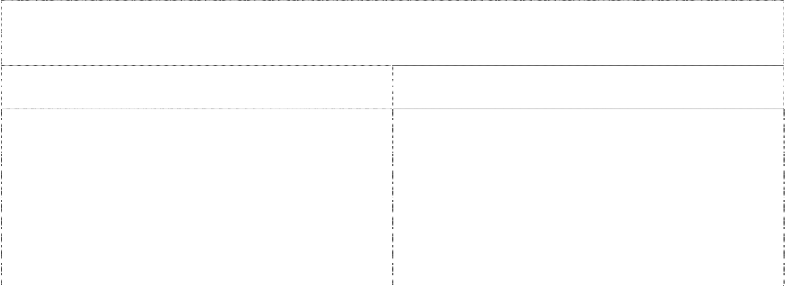

|  |  |
| --- | --- |
| **Standard** | **Indicators** |
| **Pedagogy**  1.1 Teachers demonstrate a sound understanding of current approaches to effective teaching and learning across the curriculum, (these approaches will also be informed by research into approaches that are most appropriate for the Tongan context) | * Differentiated instruction (i.e. adjustment of concepts, level of difficulty, amount of work) is used to meet learning needs of all students. * Standard achieved on teacher appraisal form * Use of a wide range of teaching strategies and approaches- strategic questioning, brainstorming, role play, narrative, project work, peer education, games * Classroom observations indicate a mix of whole group, small group and individual instruction |
| 1.2 Teachers evaluate and reflect on teaching practice and use this to inform planning | * Teachers use their knowledge of their students and information about achievement to adjust their teaching and inform their pedagogical approach * Planning aligns with curriculum, instruction, practice and |

assessment to promote student achievement

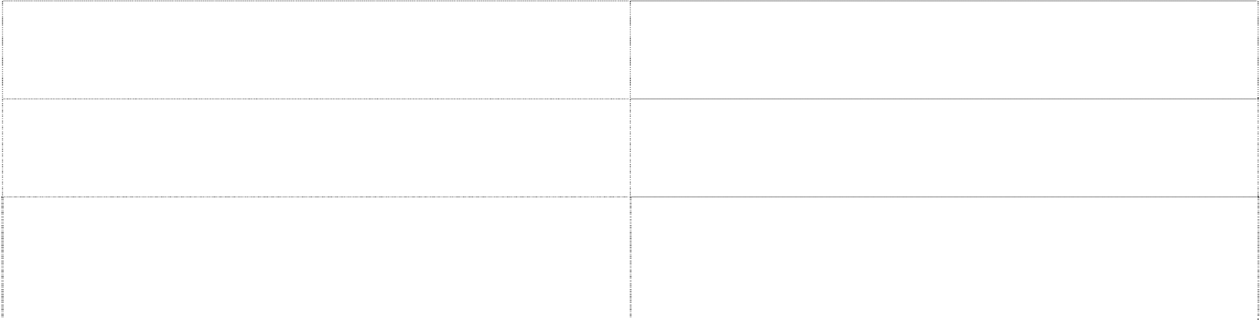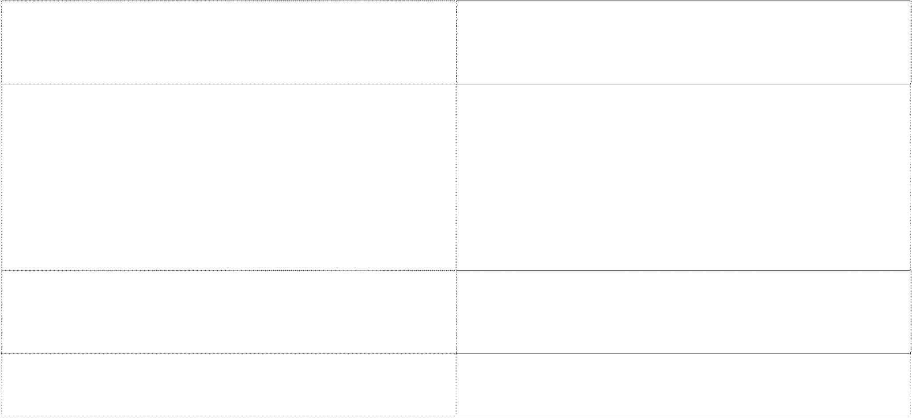

|  |  |
| --- | --- |
|  | * Teachers use feedback to inform planning * Planning is evident and identifies learning outcomes and student activities |
| 1.3 Teachers recognize individual differences in approaches to learning and student interest and provide for this diversity in learning experiences they develop. | * Vary lessons to meet needs of visual, auditory, kinesthetic learners * Uses a range of strategies such as group work, independent study, brainstorming |
| 1.4 Develop learning experiences that promote critical and creative thinking, problem-solving, decision-making skills and deep understanding of concepts | * Learning experiences are directly focused on providing opportunities for students to develop skills in these areas using appropriate strategies. * Student progress reflects improvement – records and samples of work are collected as evidence |
| 1.5 Teacher sets clear expectations of behavior and high expectations for learning | * Classroom rules and expectations are shared with students and parents * There are consistent and well understood school and class routines |
| 1.6 Student progress is clearly recorded and planning undertaken that assist them to work towards achieving their full potential | * Strengths and weaknesses are identified * Learning experiences are developed that assist students improve areas of weakness and continue to promote strengths * Accurate and up to date records of student’ s progress are kept * Portfolios of student’s work and progress are kept at each year level, and progress to each teacher in the primary   school and finally go with student to secondary school |
| **Assessment**  1.7 Teachers use various assessment techniques to evaluate student learning and modify instruction as appropriate | * A range of assessment tools and techniques are used e.g. short answer, role plays, checklist, presentations, standardized tests, focused analysis |
| 1.8 Teachers focus on assessment for learning and develop work plans, schemes of work and assessment concurrently | * Assessment practices focus on assessment for learning * Planning clearly reflects teachers modifying learning experiences based on evaluation of student progress |

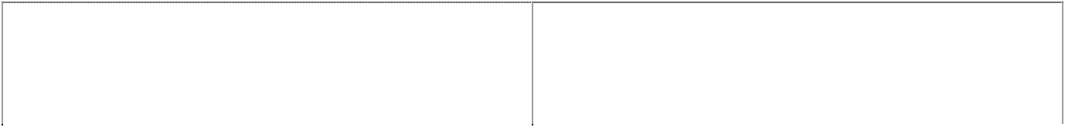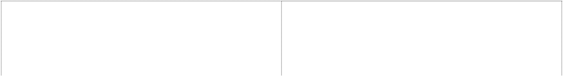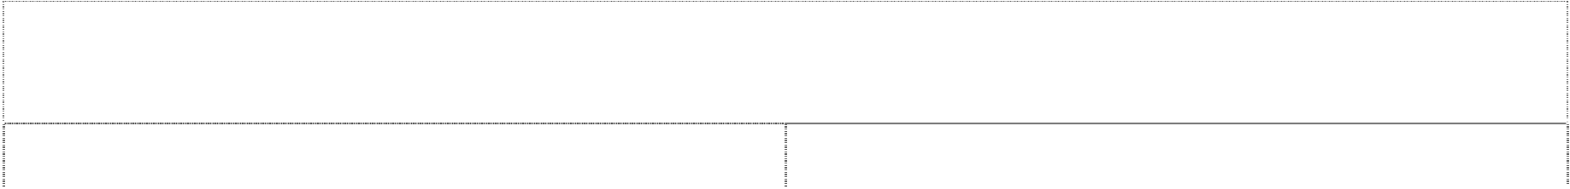

|  |  |
| --- | --- |
|  | * Planning clearly reflects that learning experiences and development of assessment are considered together in the planning process * Assessment is continuous, relevant and appropriate * Formative assessment is used regularly |
| 1.9 Assessment practices reflect the principles of authentic assessment | * Assessment processes are fair and inclusive and enable all students to demonstrate their achievements * Students receive feedback and information of progress is shared with students and parents. |

|  |  |
| --- | --- |
| **Standard** | **Indicators** |
| **Teaching capacity**  2.1 Teachers must possess a certificate of education and graduates placed on a 12-month support and guidance program | * Possesses a relevant teaching qualification (certificate of education or higher-level degree) * Records of graduate teachers are kept (Principals reviews, observations) * Graduates receive regular feedback on their progress |
| 2.2 Teachers demonstrate and implement effective planning processes and keep accurate records | * Planning clearly reflects syllabus requirements * Teacher’s planning includes daily plans, schemes of work * There are clear and accurate records of students’ progress and achievement * Use feedback and reflection to plan subsequent lessons / schemes of work |
| 2.3 Teachers demonstrate a sound knowledge and understanding of subject areas | * Teachers exhibit sufficient content knowledge to foster student learning. |

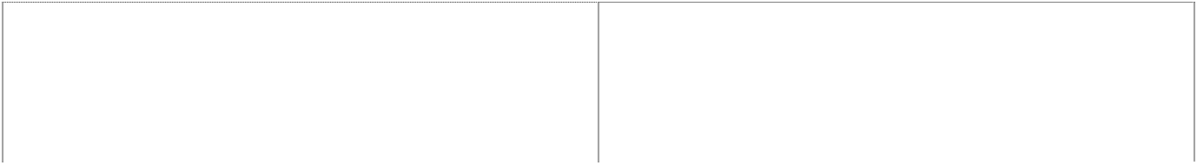

|  |  |
| --- | --- |
| 2.4 Teachers engage in professional development as a means of upgrading and maintaining skills and knowledge | * Teachers regularly attend professional development sessions when they are offered and continually seeks out opportunities to further develop their knowledge, skills and understanding and apply this in the classroom * Maintain professional reading e.g. MOE information and documents, education journals, professional association publications |
| 2.5 Teachers contribute positively to the school and its community | * Teachers participate in a range of activities that support the school and its community (both within and outside the classroom) * Teachers work collaboratively with other staff members   e.g. team teaching and class pairing. |
| **Management capacity**  2.6 Principal ensures that all staff receive appropriate curriculum and instructional materials and are provided with professional development/ training necessary to effectively use curricular and learning materials | * Relevant curriculum materials are provided to teachers * Professional development is conducted on a regular basis and focuses on a range of aspects including pedagogy, curriculum, learning, assessment. |
| 2.7 The principal demonstrates the skills necessary to lead a continuous school improvement process focused on increasing student achievement. | * The principal engages students, staff, and other stakeholders in frequent conversations about student learning and achievement * Strategies to improve student academic performance are the focus of staff meetings on a regular basis. Staff are encouraged to share research, instructional strategies, and learning experiences. * Annual school plans are developed, implemented and reviewed * School policies are developed, implemented and reviewed * Job descriptions are developed in consultation with staff |

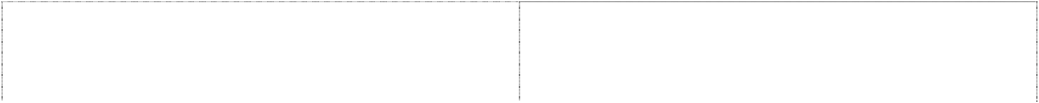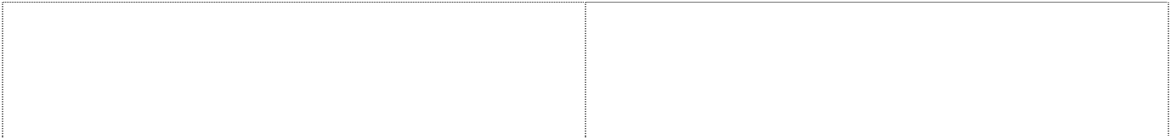

and QA.

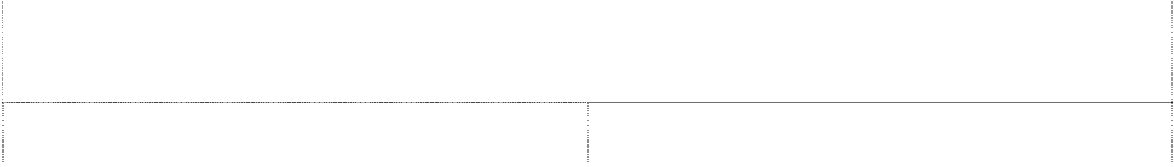

|  |  |
| --- | --- |
| 2.8 Principal establishes procedures and records to maintain efficient and effective operation of school | * A full range of required documentation/ records is kept as per Education Act and Education Policy * There is systematic process for collecting, recording and analyzing data * Process used for record keeping are transparent and accurate |
| 2.9 Principal fosters positive relationships between the school and all sectors of the community | * Encourages parents and community involvement through a range of strategies – including PTA meetings, parent teacher interviews and reporting * Ensures that confidentiality is maintained when dealing with students, teachers, staff and parents. |
| 2.10 Principal effectively and efficiently manages and uses resources, including financial resources and assets to support positive outcomes for students | * Financial resources have effectively been used to meet prioritized needs * Efficient, accurate and transparent record keeping is evident. |

|  |  |
| --- | --- |
| **Standard** | **Indicators** |
| **Learning environment**  3.1 Learning environments are safe, supportive, orderly and promote student learning | * A healthy school culture promotes social skills, conflict management so that students are prepared and ready to |



learn

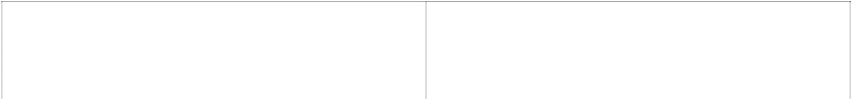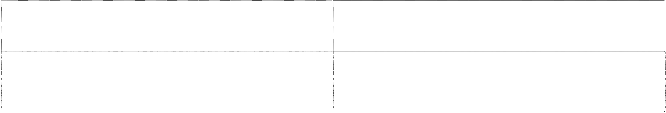

|  |  |
| --- | --- |
|  | * The physical, social, emotional wellbeing of students is considered by all staff and strategies implemented to promote this * Teachers and staff build positive relationships with   students and work to improve student attendance and dropout rates |
| 3.2 A teacher, student ratio of 1:30 is maintained  A teacher, student ratio of 1:20 for composite classes A teacher, student ratio of 1:10 for multiple classes  A teacher, student ratio of 1:25 for early childhood classes | * Staffing and enrolment records reflect maintenance of this ratio |
| 3.3 Standards of behaviour are explicit and applied consistently over time with appropriate consequences | * School policy / regulation outlines expectations and these are shared with students, parents and the community * Behaviour management policies and programs are evident in schools |
| 3.4 Schools promote a sense of shared values and respect for each other and for school property | * A culture of respect exists where relationships, trust, communication and collaboration are valued within the entire school community * The school community and classrooms reflect the schools   shared values and respect for each other and school property |
| **Facilities** (standards in this area will be further informed and developed from School Mapping information)  3.5 Buildings and facilities are well maintained and provide a safe environment for students | * Classrooms are clean, orderly and well maintained * Appropriate, sufficient and safe sanitation facilities are provided and maintained * Water supply is clean, accessible and sufficient for needs of school * Appropriate, sufficient and safe furniture is provided for students, teachers and administrators * School grounds are well maintained and safe |
|  | * Indicative figures are met |
| 3.6 Facilities minimum standards are: ( Suggested indicative figures at this point in time) |  |

**Toilets**- 1:20 for girls and female staff 2:40 +1 for each extra 30

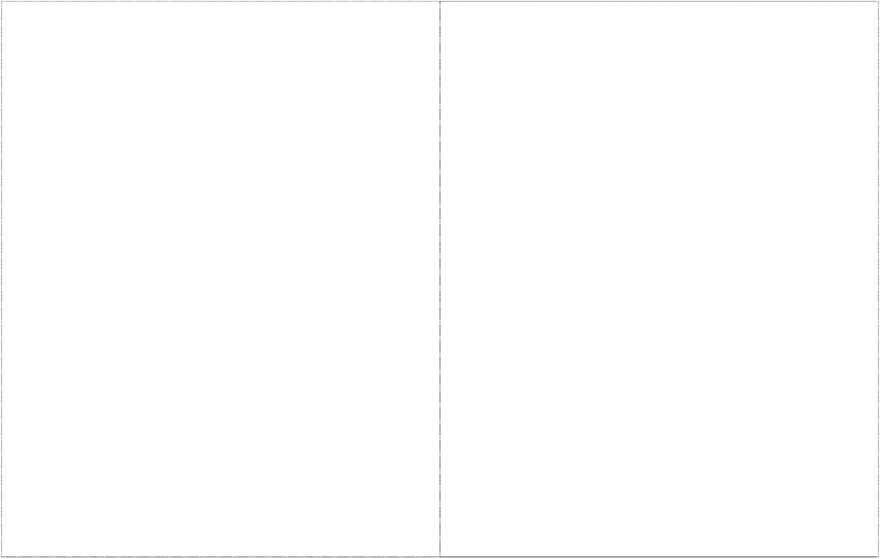

Toilets 1:30 for boys, 2:70 +1 for each extra 70- Urinals for

boys and male staff- 1:30, 2:70 + 1 for each extra 35

Hand basins- 1:60, 2:140 + 1 for each extra 140 for boys and girls.

**Classroom dimensions**- no of students x 1.6m2

All schools to have an office for the Head Teacher, minimum size suggested as 10 m2,

Staff Rooms- Not mandatory for small and medium schools , but should be provided for in larger schools

Schools are categorised by size as follows: Small < 90

Medium 90 – 180

Large over 180 students

**Teacher housing** – to be informed by school mapping findings and review of education act/ public service commission policy

###### Furniture

Student- A chair and writing surface (either table or desk) shall be provided for every student

Teacher- A chair and table or desk shall be provided for every teacher

**Classroom equipment-** Every classroom will have: 1 x blackboard

1 x locker, cupboard or bookcase 1 x pin board



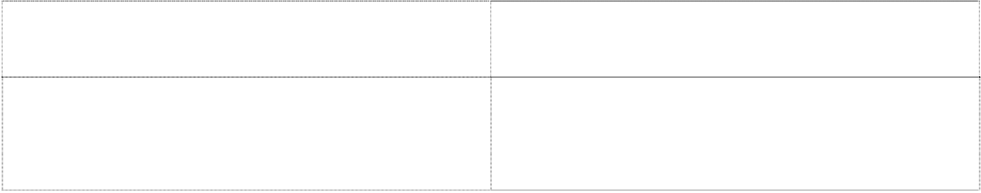

|  |  |
| --- | --- |
| **Curriculum / Teaching/ Learning resources**  3.7 Schools possess the appropriate curriculum materials (see attachment 1 for full list) | * Learning and curriculum resources are well maintained and accounted for * All curriculum materials are available and accessible in the school (complete list of minimum / essential curriculum materials to be provided by CDU) * Appropriate records of assets including curriculum, teaching and learning resources is maintained, checked   and audited. |

|  |  |
| --- | --- |
| **Standard** | **Indicators** |
| 4.1 Student achievement level on Primary national literacy and numeracy instrument ((benchmark to be informed by Bi lingual policy) | * Percentage of students achieving national literacy and numeracy benchmarks |
| 4.2 School based assessment clearly demonstrates value adding and progress of student achievement (schools maintain a portfolio for each student that contains samples of work, assessment tasks etc – at the end of primary school this portfolio  will go with the student to the secondary school) | * school based evidence and data that demonstrates continued/ improved progress of student achievement * student attendance rates * Percentage of students repeating reduced by 15% * Reduction in student dropout rates |

**Attachment 1:** **List of Curriculum Materials Class1-6, Form1 and Form 2**

|  |  |  |  |
| --- | --- | --- | --- |
| Subject | Class 1-6 | Form 1 | Form 2 |
| English | 1. English language syllabus 2. Teacher’s resources book 3. Teacher’s guide | 1. English syllabus 2. Teacher’s guide 3. Pupil’s book | 1. English syllabus 2. Teacher’s guide 3. Pupil’s book |
|  |  |  |  |
| Mathematics | 1. Mathematic syllabus 2. Teacher’s guide | 1. Mathematics syllabus 2. Teacher’s guide 3. Pupil’s book | 1. Mathematics syllabus 2. Teacher’s guide 3. Pupil’s book |
|  |  |  |  |
| Tonga Society and Culture (TSC) | 1. TSC syllabus 2. Teacher’s guide | 1. TSC syllabus 2. Teacher’s guide | 1. TSC syllabus 2. Teacher’s guide |
|  |  |  |  |
| Science | 1. Science syllabus 2. Teacher’s guide | 1. Science syllabus 2. Pupil’s booklet (1&2) 3. Teacher’s guide | 1. Science syllabus 2. Pupil’s booklet (1 & 2) 3. Teacher’s guide |
|  |  |  |  |
| Movement and Fitness (MF) | 1. MF syllabus 2. Teacher’s guide. | 1. MF syllabus 2. Teacher’s guide | 1. MF syllabus 2. Teacher’s guide |
|  |  |  |  |
| Creative Technology (CT) |  | 1. CT syllabus 2. Teacher’s guide | 1. CT syllabus 2. Teacher’s guide |
|  |  |  |  |

**Attachment 2: List of Curriculum Materials Form 3 - Form 7**

|  |  |  |  |  |  |
| --- | --- | --- | --- | --- | --- |
| Subject | Form 3 | Form 4 | Form 5 | Form 6 | Form 7 |
| English | 1. English syllabus 2. Study guide | 1. English syllabus 2. Study guide | 1. English syllabus 2. ESA Study guide | 1. English syllabus 2. ESA Study guide | 1. English syllabus 2. ESA Study guide |
|  |  |  |  |  |  |
| Mathematics | 1. Mathematics syllabus 2. Study guide | 1. Mathematics syllabus 2. Study guide | 1. Mathematics syllabus 2. ESA Study guide | 1. Mathematics syllabus 2. ESA Study guide | 1. Mathematics syllabus 2. ESA Study guide |
|  |  |  |  |  |  |
| Tonga Society and Culture (TSC) | 1. TSC syllabus | 1. TSC syllabus | 1. TSC syllabus | 1. TSC syllabus | 1. TSC syllabus |
|  |  |  |  |  |  |
| Science | 1. Science syllabus 2. Study guide | 1. Science syllabus 2. Study guide | 1. Science syllabus 2. ESA Study guide |  |  |
|  |  |  |  |  |  |
| Computer | 1. Computer syllabus 2. Study guide | 1. Com. Syllabus 2. Study guide | a. Com. syllabus  b. Study guide | a. Com. Syllabus  b. Study guide | a. Com. Syllabus  b. Study guide |
|  |  |  |  |  |  |
| Agricultural Science | 1. Agr. syllabus | 1. Agr. syllabus | a. Agr. Syllabus   1. Study guide | 1. Agr syllabus 2. Study guide | 1. Agr. Syllabus 2. Study guide |
|  |  |  |  |  |  |
| Industrial arts. | 1. Industrial arts syllabus 2. Teacher’s guide | 1. Industrial arts syllabus 2. Teacher’s guide | 1. Industrial arts syllabus 2. Teacher’s guide |  |  |
|  |  |  |  |  |  |
| Design Technology |  |  |  | 1. Design Technology syllabus |  |
|  |  |  |  |  |  |
| Economics | 1. Economics syllabus | 1. Economics syllabus | 1. Economics syllabus 2. ESA Study guide | 1. Economics syllabus 2. ESA Study guide | 1. Economics syllabus 2. ESA Study guide |
|  |  |  |  |  |  |
| Accounting | 1. Accounting syllabus | 1. Accounting syllabus | 1. Accounting syllabus 2. ESA Study guide | 1. Accounting syllabus 2. ESA Study guide | 1. Accounting syllabus 2. ESA Study guide |
|  |  |  |  |  |  |
| Chemistry |  |  |  | 1. Chemistry syllabus 2. ESA Study guide | 1. Chemistry syllabus 2. ESA Study guide |
|  |  |  |  |  |  |
| Physics |  |  |  | 1. Physics syllabus 2. ESA Study guide | 1. Physics syllabus 2. ESA Study guide |
|  |  |  |  |  |  |
| Biology |  |  | 1. Biology 2. ESA Study guide | 1. Biology 2. ESA Study guide | 1. Biology 2. ESA Study guide |
|  |  |  |  |  |  |
| Geography | 1. Geography syllabus | 1. Geography syllabus | 1. Geography syllabus 2. ESA Study guide | 1. Geography syllabus 2. ESA Study guide | 1. Geography syllabus 2. ESA Study guide |
|  |  |  |  |  |  |
| History | 1. History syllabus | 1. History syllabus | 1. History syllabus 2. ESA Study guide | 1. History syllabus 2. ESA Study guide | 1. History syllabus 2. ESA Study guide |
|  |  |  |  |  |  |
| Tourism |  |  |  |  | 1. Tourism syllabus 2. ESA Study guide |
|  |  |  |  |  |  |
| Music | Music syllabus | Music syllabus | 1. Music syllabus 2. Study Guide | 1. Music syllabus 2. Study Guide | 1. Music syllabus 2. Study Guide |
|  |  |  |  |  |  |
| Home Economics | H/E Syllabus | H/E Syllabus | 1. H/E syllabus + Content Guide | 1. H/E syllabus + Content Guide | 1. H/E syllabus + Content Guide |
|  |  |  |  |  |  |
| Japanese | 1. Japanese syllabus 2. Content Guide | 1. Japanese syllabus 2. Content Guide | 1. Japanese syllabus 2. Content Guide | 1. Japanese syllabus 2. Content Guide 3. Recommended text book | 1. Japanese syllabus 2. Content Guide 3. Recommended text book |
|  |  |  |  |  |  |
| French |  |  |  |  |  |
|  |  |  |  |  |  |
| Chinese |  |  |  |  |  |
|  |  |  |  |  |  |
| Development Studies |  |  |  | 1. DS. syllabus 2. Content Guide |  |
|  |  |  |  |  |  |
|  |  |  |  |  |  |

**INSPECTION FORMS FOR SECONDARY SCHOOLS**

**STEP 1 - Understanding MSS by Principal and staff**

|  |  |  |  |  |  |
| --- | --- | --- | --- | --- | --- |
| 1. **Teaching Methods Standards** | **Indicators** | **Source of evidence** | **Below the**  **Standard**  **1** | **Achieve the standard**  **2** | **Exceed the**  **standard**  **3** |
| **Teachers recognize individual differences in approaches to learning and provide for this diversity in learning experiences they develop** | * Vary lessons to meet needs of visual, auditory, kinaesthetic learners. * Use a range of strategies such as group work, independent study, brainstorming | Teacher appraisal form  Classroom observations  Teacher Planning documents |  |  |  |
| **b) Teaching and Management Capacity** |  |  |  |  |  |
|  |  |  |  |  |  |
| **c) Learning Environment** |  |  |  |  |  |
|  |  |  |  |  |  |
| **d) Student Achievement** |  |  |  |  |  |
|  |  |  |  |  |  |
| **e) Overall School Performance** |  |  |  |  |  |

**STEP 2 - The School Profile**

|  |  |  |  |  |  |  |  |  |  |  |  |  |  |  |  |  |  |  |  |  |  |  |  |  |
| --- | --- | --- | --- | --- | --- | --- | --- | --- | --- | --- | --- | --- | --- | --- | --- | --- | --- | --- | --- | --- | --- | --- | --- | --- |
|  | **School Name:** | | | | |  | | | | | | | | | | | | | | | | | | |
|  | **PRINCIPAL NAME:** | |  | | | | | | | | | **Date of Birth:** | |  | | | | | | | | | | |
| **Qualification:** | |  | | | | | | | | | | |
|  | **Students’ Enrolment** | **Year 7** | | **R** | **Year 8** | | **R** | **Year 9** | **R** | | **Year 10** | | **R** | | **Year 11** | | **R** | **Year 12** | **R** | | **Year 13** | | **R** |
|  | **Male** |  | |  |  | |  |  |  | |  | |  | |  | |  |  |  | |  | |  |
|  | **Female** |  | |  |  | |  |  |  | |  | |  | |  | |  |  |  | |  | |  |
|  | **Staff Name** | | | **DOB** | **Qualifications** | | | | | **Classes taught** | | | | | | **School taught at/years in each school** | | | | **Year** | | **Teacher registration** | |
|  |  | | |  |  | | | | |  | | | | | |  | | | |  | |  | |
|  |  | | |  |  | | | | |  | | | | | |  | | | |  | |  | |
|  |  | | |  |  | | | | |  | | | | | |  | | | |  | |  | |
|  |  | | |  |  | | | | |  | | | | | |  | | | |  | |  | |
|  |  | | |  |  | | | | |  | | | | | |  | | | |  | |  | |
|  |  | | |  |  | | | | |  | | | | | |  | | | |  | |  | |
|  |  | | |  |  | | | | |  | | | | | |  | | | |  | |  | |
|  |  | | |  |  | | | | |  | | | | | |  | | | |  | |  | |
|  |  | | |  |  | | | | |  | | | | | |  | | | |  | |  | |
|  |  | | |  |  | | | | |  | | | | | |  | | | |  | |  | |
|  |  | | |  |  | | | | |  | | | | | |  | | | |  | |  | |
|  |  | | |  |  | | | | |  | | | | | |  | | | |  | |  | |
|  |  | | |  |  | | | | |  | | | | | |  | | | |  | |  | |
|  |  | | |  |  | | | | |  | | | | | |  | | | |  | |  | |
|  |  | | |  |  | | | | |  | | | | | |  | | | |  | |  | |
|  |  | | |  |  | | | | |  | | | | | |  | | | |  | |  | |
|  |  | | |  |  | | | | |  | | | | | |  | | | |  | |  | |
|  |  | | |  |  | | | | |  | | | | | |  | | | |  | |  | |
|  |  | | |  |  | | | | |  | | | | | |  | | | |  | |  | |
|  |  | | |  |  | | | | |  | | | | | |  | | | |  | |  | |

1. **Staff and student Details**

**2: Facilities**

|  |  |  |  |  |  |  |
| --- | --- | --- | --- | --- | --- | --- |
| **FACILITIES** | | | | | | |
|  | Type of materials used | Number | Year of construction |  | | |
| Buildings |  |  |  | Good | Fair | Poor |
|  |  |  |  |  |  |  |
|  |  |  |  |  |  |  |
|  |  |  |  |  |  |  |
| Power supply |  |  |  |  |  |  |
|  |  |  |  |  |  |  |
|  |  |  |  |  |  |  |
| Water supply |  |  |  |  |  |  |
|  |  |  |  |  |  |  |
|  |  |  |  |  |  |  |
| Toilets |  |  |  |  |  |  |
|  |  |  |  |  |  |  |
|  |  |  |  |  |  |  |
| Communication available: phone, fax, email, radio |  |  |  |  |  |  |
|  |  |  |  |  |  |  |
|  |  |  |  |  |  |  |
| Other |  |  |  |  |  |  |
|  |  |  |  |  |  |  |

**3: Resources**

|  |  |  |  |  |  |  |  |  |  |  |  |  |  |  |  |  |
| --- | --- | --- | --- | --- | --- | --- | --- | --- | --- | --- | --- | --- | --- | --- | --- | --- |
|  | **RESOURCES** | | | | | | | | | | | | | | | |
| Subject | |  | F/1 | Number | F/2 | Number | F/3 | Number | F/4 | Number | F/5 | Number | F/6 | Number | F/7 | Number |
| English | | Syllabus |  |  |  |  |  |  |  |  |  |  |  |  |  |  |
|  | | T/Guide |  |  |  |  |  |  |  |  |  |  |  |  |
| P/Book |  |  |  |  |  |  |  |  |  |  |  |  |
| Mathematics | | Syllabus |  |  |  |  |  |  |  |  |  |  |  |  |  |  |
|  | | T/Guide |  |  |  |  |  |  |  |  |  |  |  |  |  |  |
| P/Book |  |  |  |  |  |  |  |  |  |  |  |  |  |  |
| Tongan Language | | Syllabus |  |  |  |  |  |  |  |  |  |  |  |  |  |  |
|  | | T/Guide |  |  |  |  |  |  |  |  |  |  |  |  |  |  |
| P/Book |  |  |  |  |  |  |  |  |  |  |  |  |  |  |
| Tonga | | Syllabus |  |  |  |  |  |  |  |  |  |  |  |  |  |  |
|  | | T/Guide |  |  |  |  |  |  |  |  |  |  |  |  |  |  |
| P/Book |  |  |  |  |  |  |  |  |  |  |  |  |  |  |
| Science | | Syllabus |  |  |  |  |  |  |  |  |  |  |  |  |  |  |
|  | | T/Guide |  |  |  |  |  |  |  |  |  |  |  |  |  |  |
| P/Book |  |  |  |  |  |  |  |  |  |  |  |  |  |  |
| Computer | | Syllabus |  |  |  |  |  |  |  |  |  |  |  |  |  |  |
|  | | T/Guide |  |  |  |  |  |  |  |  |  |  |  |  |  |  |
| P/Book |  |  |  |  |  |  |  |  |  |  |  |  |  |  |
| Agriculture | | Syllabus |  |  |  |  |  |  |  |  |  |  |  |  |  |  |
|  | | T/Guide |  |  |  |  |  |  |  |  |  |  |  |  |  |  |
| P/Book |  |  |  |  |  |  |  |  |  |  |  |  |  |  |
| Music | | Syllabus |  |  |  |  |  |  |  |  |  |  |  |  |  |  |
|  | | T/Guide |  |  |  |  |  |  |  |  |  |  |  |  |  |  |
| P/Book |  |  |  |  |  |  |  |  |  |  |  |  |  |  |
| Remarks | | | | | | | | | | | | | | | | |

**4. Student Achievement**

|  |  |  |  |  |  |  |  |  |  |  |  |  |
| --- | --- | --- | --- | --- | --- | --- | --- | --- | --- | --- | --- | --- |
| **Student achievement** | **Internal Assessment** | | | | | | ***External Assessment ( TFSC and TNFSC of previous year)*** | | | | | |
|  | **% Pass** | **Below Average** | **Average** | **Above Average** | | | **% Pass** | **Below Average** | **Average** | **Above Average** | | |
|  |  | **Beginner** | **Achieved** | **Merit** | **Excellent** | **Distinction** |  | **Beginner** | **Achieved** | **Merit** | **Excellent** | **Distinction** |
| Form 1 |  |  |  |  |  |  |  |  |  |  |  |  |
| Form 2 |  |  |  |  |  |  |  |  |  |  |  |  |
| Form 3 |  |  |  |  |  |  |  |  |  |  |  |  |
| Form 4 |  |  |  |  |  |  |  |  |  |  |  |  |
| Form 5 |  |  |  |  |  |  |  |  |  |  |  |  |
| Form 6 |  |  |  |  |  |  |  |  |  |  |  |  |
| Form 7 |  |  |  |  |  |  |  |  |  |  |  |  |

**Step 3 – Establishing levels of achievement in 4 key areas**

1. **Teaching Methods**

|  |  |  |  |  |  |
| --- | --- | --- | --- | --- | --- |
| **Standard** | **Indicators** | **Evidence that supports level of achievement** | **Below the standard** | **Achieve the standard** | **Exceed the standard** |
| Pedagogy  1.1 effective teaching and learning across the curriculum most appropriate to Tongan context | * differentiated instruction  * internal teacher appraisal  * use variety of teaching strategies  * classroom observation |  | 1. Whole class teaching most of the time  2. Little choice of activity  3. No allowance is made for children of differing abilities  4. Students show little interests in their work  5. Little or no written or oral feedback to students  6. Teacher is usually found at the desk  7. Little or no use of resources  8. Tasks not suitable for many students | 1. Students usually engage in the work and on task  2. Students are offered choices of task  3. There is a mix of individual, group and whole class activities  4. There will be a variety of approaches; discussions, reports, experiments, presentations, etc  5. Tasks are appropriate  Teacher contributes to professional discussions | 1. Students always engaged in tasks  2. There is a variety of activity for students  3. Teacher is able to inform others about teaching strategies  4. The teaching is always looking for different teaching strategies  5. Classroom activities are always challenging for students |
| 1.2 - effective teaching practice to inform planning | *Adjust teaching based on students’ achievement level and learning styles |  | 1. There is no evidence of teacher evaluation and reflection  2. There is no written evaluation in planning book  3. Planning is not based on student need or interest  4. Written planning is minimal  5. Planning is unrelated to curriculum  6. Planning does not show learning outcomes or success criteria or student tasks  7. Teacher do not adjust to learning needs | 1. Planning is evident  2. Planning shows learning outcomes and student tasks  3. Teacher usually plan to student needs  4. Planning aligns with curriculum  5. Teachers able to adjust their teaching to student needs.  6. Written evaluation is shown in planning book.  7. Teachers willing to talk about their teaching. | 1. Teachers frequently talk about their class work and look to improving strategies.  2. Written planning shows amendment.  3. Written evaluation is evident  4. Teachers able to adjust teaching “mid-stream” as needs become apparent.  5. Following assessment, teaching make adaptation to their teaching plans. |
| 1.3 - awareness of differences in students’ learning styles to inform teaching planning | * Vary lessons based on students’ learning styles  * Use a range of teaching strategies |  | 1. Lessons are the same for all students  2. Tasks are routine and activities are much the same for all students.  3. Little or no individual guidance is given.  4. Much work is pen and paperwork. | 1. Differentiated strategies are evident – individual tasks, group, whole class.  2. Student often use equipment to help them  3. The classroom programme is balanced and all curriculum areas are covered.  4. Student work is evident in classroom displays. | 1. the range of teaching strategies is evident.  2. Teachers are always busy with the students.  3. Choice is given in tasks so that learning outcome may be met through a range of tasks. |
| 1.4 – teacher planning/preparation to promote variety and depth of learning skills | * Teaching strategies to focus on providing learning opportunities to develop a variety of skills  * Student progress reflects improvement |  | 1. Questions are usually What, When, Who & Where.  2. Assignments are usually… find out about…  3. Classroom is usually routine exercises.  4. Students work shows much similarity and little variety.  5. Students usually engaged in lower order thinking.  6. Students tasks are routine practice and reproduction of knowledge. | 1. Class questions may include explains, what was this choice made, etc.  3. Some tasks include construct, design, devise.  4. Student work shows some choice and variety  5. Students engaged in low order and some higher order thinking. |  |
| 1.5 – Sets clear expectations of behavior and high expectations for learning | *Student handbook to be available to parents |  | 1. No school rules or expectations are stated.  2. Rules are stated but teachers do not enforce the rules or follow up incidents.  3. There are frequent playground disruptions.  4. Bullying is a problem in the school.  5. Teachers do not carry out school duties  6. Teachers allow children to fail  7. Follow up of student work is minimal.  8. Little or no improvement in student work.  9. There is little or no reflection on student performance. | 1. School rules are clearly seen in classrooms.  2. Students get on well with each other and care for one another.  3. Teachers intervene in any playground disruption.  4. Incidents of poor behavior are followed up with advice & guidance and if necessary, consequences.  5. Parents are informed of serious misdemeanor.  6. teachers always follow up students especially where poor performance.  7. Student work is always marked. | 1. there is a clear policy on Pastoral Care.  2. There is a very positive feel about the school.  3. Where the school notes poor performance in a curriculum area, there is a focused action plan to make improvement.  4. There is frequent review of student performance.  5. The school has a specific area of focus for curriculum improvement.  6. There is evidence of progress by all students.  7. teachers report to parents formally & informally.  8. There is an underlying belief that “all students can learn”. |
| 1.6 – students’ progress are recorded | *Progress reports |  | 1. There is no record kept for individual student performance.  2. Student work is seldom marked.  3. there is no individual student portfolio.  4. Student strengths or weaknesses are not identified by teacher.  5. Tasks are set without reference to student ability. | 1. Each student has a portfolio with samples of work  2. teacher has record of student test results  3. the teacher has anecdotal notes of student performance  4. When setting tasks, teacher takes into account student needs and abilities  5. the teacher can identify student strengths & weaknesses | 1. the student Portfolio is rich with student work samples  2. Portfolio is current  3. Teacher has considerable notes on each student’s performance  4. Teacher knows and records needs of students and plans accordingly  5. Teacher notes “next steps” for students learning and uses the notes  6. The students knows where progress has been made  7. The school programme is wide ranging  8. the school uses marking rubrics |
| Assessment  1.7 - various assessment techniques are used to evaluate student learning and modify instruction as appropriate | *a range of assessment tools and techniques are used |  | 1. No assessment of student learning is taking place  2. No record of student learning is evident  3. there are few forms of student assessment eg. Only an occasional maths test  4. Samples of work are collected but there is no annotation  5. Work is marked with ticks or “seen” or “good” and without any helpful comments | 1. There is evidence of various forms of assessment: checklist, scores, anecdotal notes, helpful comments on student work, etc.  2. Teachers are actively giving guidance to students  3. Teachers are always marking student work  4. There is some evidence of suggestions how student may make improvements | 1. There is evidence of student assessment in all subjects  2. Marking criteria is evident  3. Students are informed of marking criteria  4. Assessment results are analyzed to get an overview of student learning  5. There is evidence of modification of teacher strategies when analyses show that it is necessary  6. There is evidence of peer and self & peer assessment  7. There is evidence of student marking changes in their work for improvement. |
| 1.8 – Teachers focus on assessment for learning | * Assessment practices focus on assessment for learning  * Assessments are clearly stated in the planning  * Assessment is continuous/relevant and appropriate  * Formative assessment is regular |  | 1. No assessment of student learning is taking place  2. There are few forms of student assessment eg. Only an occasional maths test  3. Samples of work are collected but there is no annotation  4. Planning shows no relationship to student needs or students’ assessment | 1. Formative assessment process are evident  - Learning Outcome  - Success Criteria  - Questioning  - Feedback  - Next steps  - Self & Peer evaluation  2. Marking is regular  3. Helpful comments are given to students for improvement.  4. Teachers give oral & written feedback  5. Planning is related to student assessment.  6. There is a programme of student assessment | 1. Learning outcomes and success criteria are displayed.  2. Students first evaluate their own work against success criteria.  3. Student work shows editing/re-working  4. Peer and self -evaluation is evident  5. Teachers have records that show marks, notation, comments about student work.  6. Students generate their own questions.  7. Students show independence in learning  8. Teachers prepare checklists for students to use in self and peer evaluation  8. The school has written policy & programme of student assessment. |
| 1.9 – Assessment to be authentic | * Assessment process to be fair and inclusive  * Information of student progress are shared with students and parents |  | 1. Little or no assessment of student learning is taking place.  2. Teacher has little knowledge and understanding of student assessment  3. Students get little or no useful feedback on work  4. Students report are brief and often use phrase such as; must work harder, work works well, - rather than comment on actual skills development.  5. Reports to parents do not comment on students learning progress and achievement. | 1. Summative, Formative and Diagnostic assessment is evident.  2. Marking is regular.  3. Helpful comments are given to all students for improvement.  4. Teachers give oral & written feedback.  5. Clear informative information is available for all parents.  6. Teachers know if students are meeting learning outcomes and will have supporting information | 1. Learning outcomes and success criteria are displayed for students.  2. Peer and self -evaluation is evident.  3. Teachers have records that show marks, notations, comments about student work.  4. Information is available for class and school wide review.  5. Teachers will have tracking sheets to monitor students’ performance.  6. Data is used to monitor school wide performance. |

**Circle the appropriate Standard box**

|  |  |  |
| --- | --- | --- |
| **Standard achieved** | | |
| **Below** | **Achieve** | **Above** |

1. **Teaching and Management Capacity**

|  |  |  |  |  |  |
| --- | --- | --- | --- | --- | --- |
| **Standard** | **Indicators** | **Evidence that supports level of achievement** | **Below the Standard** | **Achieve the Standard** | **Exceed the Standard** |
| Teaching capacity  2.1 Teachers must possess a certificate of education and graduates placed in a 12-month probation period | **\*** Possesses a relevant teaching qualification (Certificate of Education or higher-level degree)  * Records of graduate teachers are kept (Principals reviews, observations  * Graduates receive regular feedback on their progress |  | 1. Most teachers do not have a formal Teaching or University Graduate qualification.  2. Graduate teachers do not receive any support or guidance.  3. There is no record, or limited record of advice and guidance given to probationary teachers. | 1. Most teachers have a formal teacher qualification or a university degree.  2. First year teachers have a formal advice & guidance programme.  3. Records are kept of observations and advice & guidance given to probationary teachers.  4. Probationary teachers are given regular feedback on their performance. | 1. The school has a formalized programme of support for probationary teacher.  2. Records of observations and advice & guidance are kept, and copies given to the probationary teachers.  3. Any teacher without a formal teaching qualification is given supervision by a qualified teacher. |
| 2.2  Teachers demonstrate and implement effective planning processes and keep accurate records | * Planning clearly reflects syllabus requirements  * Teacher’s planning includes daily plans, schemes of work  * There are clear and accurate records of students’ progress and achievement  * Use feedback and reflection to plan subsequent lessons /schemes of work |  | 1. There is no written planning.  2. Only the activity is stated.  3. Lessons frequently do not happen as written.  4. Lessons planned are unsuitable for the students.  5. there are no records or few records of student progress and achievements.  6. Planning takes no account of previous learning.  7. Planning takes no account of range of abilities of students. | 1. Written planning is evident.  2. Planning meets syllabus requirements  3. Written planning shows Learning Outcomes, Success Criteria, Tasks.  4. There are no records of student performance.  5. Lessons are sequential and show modification or development from previous lessons. | 1. Detailed written planning is evident.  2. Planning indicates a variety of activity.  3. written planning shows Learning Outcomes, Success criteria, Tasks.  4. Planning allows for range of student abilities.  5. Plans shows innovation and creativity,  6. Planning shows modification to meet student needs.  7. Planning shows effort to engage students.  8. Student records are detailed, note strengths, and areas for improvement. |
| 2.3  Teachers demonstrate a sound knowledge and understanding of subject areas | *Teachers exhibit sufficient content knowledge to foster student learning |  | 1. Teachers has no knowledge or understanding of subjects being taught.  2. Teacher relies heavily on text book for subject information.  3. Teacher is unsure of next steps in learning.  4. Basic errors or student misunderstanding is missed.  5. Teachers cannot answer student questions.  6. Teacher is unable to plan supplementary tasks.  7. Students show little interest in their learning. | 1. Teachers shows basic knowledge of subject being taught.  2. The teacher is able to find information and develop supplementary tasks.  3. Teacher is able to question students on their work.  4. Teacher is able to give direction to students. | 1. Most teachers clearly display depth of knowledge and understanding of their subjects.  2. Teacher is able to guide students and give further direction.  3. Teachers are able to foster student thinking.  4. Student work shows high level of engagement and achievement. |
| 2.4  Teachers engage in professional development as a means of upgrading and maintaining skills and knowledge | * Teachers regularly attend professional development sessions when they are offered and continually seeks out opportunities to further develop their knowledge, skills and understanding and apply this in the classroom  * Maintain professional reading e.g. MET information and documents, education journals, professional association publications.  Staff meetings regularly held on teaching/learning issues. |  | 1. There are no staff meetings on professional matters.  2. There is no communication on teaching or learning matters.  3. Teachers do not attend association meetings. | 1. There are occasional meetings on professional matters attended by staff.  2. Professional papers are available for staff to read.  3. Teachers usually attend association meetings.  4. Teachers sometimes engage in discussion about teaching & learning matters. | 1. Time frequently set aside for professional discussion.  2. Teachers willingly attend association meetings.  3. Papers readily available for professional reading.  4. Teachers willing to do extra professional study.  5. Teachers use internet to find professional readings.  6. There is a staff library for professional publications and **there are often new materials.** |
| 2.5  Teachers contribute positively to the school and its community | * Teachers participate in a range of activities that support the school and its community (both within and outside the classroom)  -Teachers work collaboratively with other staff members e.g. team teaching and class pairing. |  | 1. Teachers are frequently late or absent from class.  2. Teachers are often outside classroom or sitting at desk and are not involved with students  3. Teacher leave work as soon as the last bell rings  4. There is no teacher participation in staff meetings.  5. Teachers do not carry out school duties.  6. Teacher absence rate is high.  7. Teachers do not involve themselves in school- community activities. | 1. Teachers are frequently working together and sharing ideas.  2. Teachers attend PTA meetings.  3. Teachers are willing to coach sports team or take extra classes.  4. Teachers plan together.  5. Some team teaching evident.  6. Teachers are always present at the school.  7. Teachers are involved in school-community activities. | 1. Teachers fully involved in school decision making.  2. Teaching reflecting and planning together to make the school better.  3. Teachers are involved in school-community meetings and events.  4. Teachers spend more than the usual time at school.  5. Teacher absence rate is very low. |
| Management capacity  2.6  Principal ensures that all staff receive appropriate curriculum and instructional materials and are provided with professional development/training necessary toeffectively use curricular and learning materials | * Relevance curriculum materials are provided to teachers  * Professional development is conducted on a regular basis and focuses on a range of aspects including pedagogy, curriculum. Learning, assessment |  | 1. The school has few resources for teachers.  2. Textbooks are in poor condition.  3. The school does not supply charts, papers, markers, etc. for teachers.  4. Resources are in the school, but no training has been provided for the use of materials.  5. There are no staff meeting on professional matters. | 1. The school has n adequate supply of student texts and teacher manuals.  2. New resources are purchased when money is available.  3. There is a “stock list” or “asset register” showing available curriculum resources.  4. When materials are purchased teachers are trained in their purpose and use.  5. There are regular staff meetings on teaching and learning matters. | 1. There is a variety of resources or curriculum materials for teachers to use.  2. Spending on resources is given a priority.  3. There is a plan of focused purchasing of curricula materials.  4. Teachers are using the resources in a variety of ways.  5. Frequent staff discussion on teaching/learning materials formal & informal.  6. The school has planned focus on improving student performance as shown in the Annual Plan. |
| 2.7  The Principal demonstrates the skills necessary to lead a continuous school improvement process focused on increasing student achievement | * The Principal engages students, staff, and other stakeholders in frequent conversations about student learning and achievement  * Strategies to improve student academic performance are the focus of staff meetings on a regular basis  * Staffs are encouraged to share research, instructional strategies, and learning experiences.  * Annual school plans and Strategic plans are developed, implemented and reviewed  * School policies are developed, implemented and reviewed  * All staff have agreed and signed Job descriptions |  | 1. Few staff or parent meetings.  2. Student performance is not discussed.  3. Professional matters are not discussed in staff meetings.  4. Scant school documentation on school operations and expectations.  5. No Annual Plan  6. Many Minimum Service Standards not met.  7. No up-to-date staff Job Descriptions.  8. Little or no improvement in student work.  9. There is little or no reflection on student performance. | 1. Professional matters are discussed in staff meetings.  2. The Principal has information on student achievement.  3. At PTA meetings the principal discusses learning and teaching with the parents.  4. Parent Information evenings are held.  5. Parents are informed of student progress.  6. Teachers have up-to-date Job  Descriptions.  7. The school has an Annual Plan for improvement. | 1. There is a planned in-depth focus on student achievement.  2. Staff share information on student achievement and contribute to improvement strategies.  3. There is a programme of policy and curriculum review.  4. There is frequent review of student performance.  5. School documentation covers all aspects of school operations.  6. A Strategic Plan is being implemented.  7. Job descriptions are reviewed annually.  8. School improvement is evident.  9. The Principal is well respected by staff and parents. |
| 2.8  Principal establishes procedures and records to maintain efficient and effective operation of school | *A full range of required documentation/ records |  | 1. There is little or no school documentation on school operations or expectations.  2. There is little or no school data on student performance.  3. The school Administration Manual is out of date.  4. There is no Annual Plan or school calendar.  5. No up-to-date staff Job Descriptions. | 1. The documents, as listed over page, are available.  2. The Principal has information on student achievement.  3. There is an orderly filing system.  4. The school has an Annual Plan for improvement.  5. Class lists are easily retrievable.  6. Information on student performance is retrievable. | 1. School documentation covers all aspects of school operations and is up-to-date and frequently revised.  2. The school has an Administration Handbook for all staff.  3. A Strategic Plan is being implemented.  4. Job Descriptions are reviewed annually. |
| 2.9  Principals fosters positive relationships with staff, students  and all sectors of the community | * Encourage parents and community involvement through a range of strategies – including PTA meetings, parent teacher interviews and reporting  * Ensure that confidentially is maintained when dealing with students, teachers, staff and parents  * Fosters positive relations with staff and students |  | 1. There are no meetings for parents.  2. Parents are discouraged from meeting with teachers.  3. Parent attendance at meetings is small.  4. There is little or no communication between the school and the community.  5. Parents have complained about “not knowing”.  6. The Principal does not attend meetings of PTA, Board/Ministry/Principal association, etc.  7. Confidential information sometimes become “public knowledge”. | 1. There is a parent meeting usually once a term.  2. Newsletters are sent out regularly.  3. Staff are welcoming to parents and visitors.  4. Parent interviews are held at least twice a year.  5. Student reports are sent out at least twice a year.  6. Parents feel free to disclose information to staff.  7. Parents are sometimes involved in school activities. | 1. The Principal is often seen publicly as is in high regard by the community.  2. The school has an “Open door” Policy.  3. A school representative is always involved in school/education meetings.  4. Information of student performance over the years is always available at any time to the parents concerned.  5. The school uses the media frequently to convey school information.  6. The school seeks community input & feedback from time -to time.  7. Parents are frequently involved in school activities. |
| 2.10  Principal effectively and efficiently manages and uses resources, including financial resources and assets to support positive outcomes for students | * Financial resources have effectively been used for effective operation of school and to meet prioritized needs  * Efficient, accurate and transparent record keeping is evident |  | 1. Resources are minimal.  2. Resources are in poor repair.  3. Little money is spent on learning & ‘teaching resources.  4. No budget is prepared.  5. Spending is unplanned and “ad hoc”.  6. Little is done to care for or enhance resources. | 1. An annual school plan and budget is prepared.  2. The stock list/asset register is up-to-date.  3. The school has adequate resources.  4. Resources re kept in good condition.  5. TSGP documentation complies with requirements.  6. The Principal works with the PTA to provide funds for resources.  7. Students treat resources with care. | 1. A 3 – 5-year Strategic Plan is prepared.  2. A whole school budget is prepared and this guides expenditure.  3. Teachers have suitable resources for all areas of the curriculum.  4. The school has a written policy on purchase and care of resources.  5. The Principal works actively with community and public agencies to enhance school resources.  6. There is a workable system for tracking assets.  7. The school has an asset replacement plan. |

**Circle the appropriate Standard box**

|  |  |  |
| --- | --- | --- |
| **Standard achieved** | | |
| **Below** | **Achieve** | **Above** |

1. **Learning Environment**

|  |  |  |  |  |  |
| --- | --- | --- | --- | --- | --- |
| **Standard** | **Indicators** | **Evidence that supports level of achievement** | **Below the standard** | **Achieve the standard** | **Exceed the standard** |
| Learning environment  3.1  Learning environments are safe, supportive, orderly and promote student learning | *A healthy/ school culture promotes social skills, conflict management so that students are prepared and ready to learn  * The physical, social, emotional wellbeing of students is considered by all staff and strategies implemented to promote this  * All students are treated with respects, at all times.  * Teachers and staff build positive relationships with students and work to improve student attendance and dropout rates |  | 1. Student attendance is not regular and pupils run away.  2. There is little student work on display.  3. Students are often seen crying.  4. The classroom and property are untidy.  5. Desks and chairs are damaged.  6. Bullying is a problem.  7. Teachers “put down” students.  8. Students are not listened to.  9. School morale is low.  10. There are frequent incidents. | 1. Students are happy to be at school.  2. Rooms are tidy and student work is displayed.  3. Misdemeanor is usually dealt with.  4. The school is sufficiently resourced.  5. Teachers usually listen to their students.  6. Playground activity is usually busy.  7. Equipment and resources are usually in good repair.  8. Students know the school ways.  9. There are few incidents. | 1. There is a policy of Pastoral Care which teachers follow.  2. Classrooms are attractive and inviting.  3. There are no playground fights.  4. Teacher do not hit students nor yell at them.  5. Students are clearly valued, supported and friendly relationships are evident and felt.  6. Students and teachers enjoy the school.  7. Students show leadership and responsibility. |
| **3.2**  A teacher, student ratio of 1:30 is maintained.  A teacher, student ration of 1:20 for composite classes.  A teacher, student ration of 1:10 for multiple classes | *Staffing and enrolment records reflect maintenance of this ratio |  |  |  |  |
| **3.3**  Standards of behavior are explicit and applied consistently over time with appropriate consequences | *School policy/regulation outlines expectations and these are shared with students, parents and the community  Behaviour management policies and programmes are evident in schools |  | 1. There are no clear student behaviour/ guidelines/ rules/ expectations.  2. Parents have little/ no idea of school expectations and processes.  3. There is inconsistency in follow up of student misdemeanors.  4. Students are often seen crying.  5. Students are often seen outside the classroom because of a class misdemeanor.  6. Bullying is a problem.  7. There are frequent incidents.  8. Teachers o not want to be on duty because of poor playground and behaviour. | 1. Clear guidelines bout conduct, uniform, etc. are posted in classrooms.  2. Students know the school ways.  3. Parents are informed of behaviour expectation on enrolment/ newsletter/ meetings.  4. Students are happy to be at school.  5. Misdemeanors re usually dealt with.  6. Teachers usually listen to their teachers.  7. Playground activity is usually busy.  8. Parents know how to address issues. | 1. The school has a set of clear written values.  2. There is a clear written policy on Pastoral care.  3. Where necessary the school has implements action or programme to raise standards.  4. Students are clearly valued, supported and friendly relationships are evident.  5. Parents are involved to improve student behaviour.  6. Suspensions and expulsions are few and only for very serious misconduct. |
| **3.4**  Schools promote a sense of shared values and respect for each other and for schools’ property | *A culture of respect exists where relationships, trust, communication and collaboration are valued within the entire school community  * Staff and students show respect for one another and for school property |  | 1. Morale among staff and students is low.  2. Property and resources are in poor state.  3. There is no consensus on shared values.  4. Bickering is evident amongst student, staff and community.  5. There is community disquiet about the school. | 1. There is a set of written values under-pinning the school.  2. What people think and how people act, is in accordance with the stated values.  3. the school is a comfortable place. | 1. The school has set of clear written values.  2. There is frequent reflection and referral to school values.  3. The school values come out of community consultation. |
| Facilities (standards as in School Mapping information)  3.5 Buildings and facilities to be quality in maintenance and safety for students | *Classrooms are clean, orderly and well maintained  * Appropriate, sufficient and hygienic sanitation facilities are provided and maintained  * Water supply is clean, accessible and sufficient for needs of school  * Appropriate, sufficient and safe furniture is provided for students, teachers and administrators  * School grounds are well maintained and safe |  | 1. Classroom are untidy, and in poor state of repair.  2. Desks and chairs need fixing.  3. Classroom walls have holes.  4. Buildings are drab.  5. Water supply is frequently unavailable.  6. Toilets are unhygienic.  7. There are too few toilets.  8. Grounds need care.  9. Roofs leak.  10. School has to be closed on a wet day. | 1. Classrooms are generally well kept.  2. Classroom furniture is in good repair.  There is an adequate supply of classroom furniture.  3.There is an adequate water supply.  4. School grounds are kept tidy. | 1. Classroom are attractive and in very good order.  2. Classroom furniture is of good quality.  3. Toilets are very clean & hygienic.  4. Students have access to drinking fountains.  5. Grounds and gardens are very well kept and attractive.  6. There are systems in place to maintain buildings & grounds. |
| 3.6  Facilities minimum standards   * Toilets * Hand basins * Classroom dimensions * Principal office * Staff rooms * Teacher housing * Furniture * Classroom equipment | *Indicative figures are met |  |  |  |  |
| Curriculum/Teaching/Learning resources  3.7  Schools possess the appropriate curriculum materials | *Learning and curriculum resources are well maintained and accounted for |  | 1. There are few or no copies of syllabus and CDU texts in the school.  2. Copies of resource are in poor repair.  3. There are no or few supporting resources in the school.  4. There is no asset register/stock list.  5. There is difficulty finding school resources. | 1. Basic syllabuses and texts are in the school.  2. There are sufficient texts- at least one text between two pupils, when required for class use.  3. Materials are in good repair  4. There is some support materials beside CDU texts.  5. School resources are listed in an up-to-date asset register/ stock list.  6. Teachers can locate resources.  7. New materials are added each year. | 1. Syllabus and a variety of texts and support materials are available for teachers and students.  2. Up-to-date support materials and resources are readily available.  3. Resources are well stored and in good repair.  4. Teachers know what resources are available and have good access to them.  5. The asset register/ stock list is current.  6. Student have copies of texts to take for homework.  7. Students have access to Internet. |

**Circle the appropriate Standard box**

|  |  |  |
| --- | --- | --- |
| **Standard achieved** | | |
| **Below** | **Achieve** | **Above** |

1. **Student Achievement**

|  |  |  |  |  |  |
| --- | --- | --- | --- | --- | --- |
| **Standard** | **Indicators** | **Evidence of level of achievement** | **Below the standard** | **Achieve the standard** | **Exceed the standard** |
| 4.1  Student achievement level on National examination results | *Percentage of students achieving national exam benchmarks |  | 1. Summative test results show that students are consistently performing poorly.  2. Few students score well in school Mid-year and Final exams as well as TFSC & TNFSC.  3. There is no support for struggling students.  4. Exercise books so standard of work below expectations. | 1. Summative test results show student success.  2. There is evidence of student progress as shown from student work samples.  3. Struggling students are given support. | 1. Summative results show progress for all students.  2. No student is allowed to fail.  3. Real effort is put into students who are not showing progress in learning.  4. The school has developed benchmarks to indicate student performance. |
| 4.2  School based assessment clearly demonstrates value adding and progress of student achievement  Subject teachers and form teachers keep a record of student assessment results | * School based evidence and data that demonstrates continued/improved progress of student achievement  * Student attendance rates  * Percentage of students repeating reduced by 15%  * Reduction in student dropout rates |  | 1. There is no evidence of student progress.  2. Student portfolios are not maintained.  3. Student attendance is not recorded.  4. More than 15% of students are repeating.  5. The student drop-out rate is large. | 1. Portfolios are kept up-to-date.  2. There is evidence of student progress.  3. Attendance records are kept.  4. Attendance rates are consistently high.  5. There are few repeaters (if any).  6. Student drop-out rate is minimal.  7. Attendance records are reviewed. | 1. Portfolios are up-to-date and used to reflect on student performance.  2. Students attendance records are reviewed.  3. Caregivers are contacted when there is unexplained absence.  4. There are o repeaters.  5. There are no students dropping out of the school.  6. The school meets caregivers whenever student absence is frequent. |

**Circle the appropriate Standard box**

|  |  |  |
| --- | --- | --- |
| **Standard achieved** | | |
| **Below** | **Achieve** | **Above** |

**Step 4 – Quality Assurance verification of the school’s level of achievement against the standards**

**Evidence and data**

|  |  |  |  |  |  |
| --- | --- | --- | --- | --- | --- |
| **Standard** | **Indicators** | **Evidence level of achievement** | **Below the standard** | **Achieve the standard** | **Exceed the standard** |
| **Pedagogy**   * 1. **– 1.6**   **Assessment**  **1.7 – 1.9** | **-**Differentiated instruction  - A wide range of teaching strategies  - Planning aligns with curriculum  - Keep a records of students’ achievements | Teacher’s planning to reflect content knowledge and to aligns with curriculum and assessments used |  |  |  |
| **-**A range of assessment tools and techniques are used  - |  |  |  |
| **Teaching and management capacity**  **2.1 – 2.10** | **-**Relevant teaching qualification  -Records of graduate teachers are kept  Planning clearly reflects syllabus requirements  **-** | Teacher appraisal form  Teacher observation  Teacher resources and planning |  |  |  |
| **-**Relevant curriculum materials  -conduct ProfessionalDevelopment is conducted  -School policies are developed, implemented and reviewed |  |  |  |
| **Learning environment**  **3.1 – 3.4**  **Resources**  **3.5**  **Toilet facilities**  **3.6**  **Curriculum materials** | -a healthy school culture promotes social skills, conflict management so that students are prepared and ready to learn  -teachers and staff build positive relationships with students and work to improve student attendance and dropout rates  - |  |  |  |  |
| **Student achievement**  **4.1**  **4.2** | **-**Percentage of students achieving national literacy and numeracy benchmarks  -School based evidence and data that demonstrates continued/improved progress of student achievement  -Student attendance rate  **-**Percentage of students repeating reduced by 15%  -Reduction in student drop out rates |  |  |  |  |

**Circle the appropriate Standard box**

|  |  |  |
| --- | --- | --- |
| **Standard achieved** | | |
| **Below** | **Achieve** | **Above** |

**Step 5 – Action Plan to improve achievement levels**

1. **Teaching Methods**

|  |  |  |  |  |  |  |  |  |
| --- | --- | --- | --- | --- | --- | --- | --- | --- |
| **Standard** | **Indicators** | **Evidence** | **STANDARD ACHIEVED** | | | **Actions to be taken/strategies used to address standards** | **Person responsible** | **Funding required** |
| **B** | **A** | **E** |  |  |  |
| **Pedagogy**  1.1 Teachers demonstrate a thorough understanding of current approaches to effective teaching and learning across the curriculum | -teachers use differentiated instruction is used to meet learning needs of all students.  -Use a wide range of teaching strategies and approaches  -classroom observations indicate a mix of whole group, small group and individual instruction  -standard achieved on teacher appraisal form | Class observation  Work plans  Principal’s observations  Teacher appraisal form |  |  |  |  |  |  |
| 1.2 Teachers evaluate and reflect on teaching practice and use this to inform planning | **-**teachers use their knowledge of their students and information about achievement to adjust their teaching and inform their pedagogical approach-planning aligns with curriculum, instruction, practice and assessment to promote student achievement  - Planning is evident and identifies learning outcomes and student activities | Teacher appraisal form  Class observations  Work plans |  |  |  |  |  |  |
| 1.3 Teachers recognize individual differences in approaches to learning and student interest and provide for this diversity in learning experiences they develop | - Vary lessons to meet needs of visual, auditory, kinesthetic learners  - Use a range of strategies such as group work, independent study, brainstorming | Teacher appraisal form  Principal observations  Class observations |  |  |  |  |  |  |
| 1.4 Teachers develop learning experiences that promote critical and creative thinking problem-solving, decision-making skills and deep understanding of concepts | - learning experiences are directly focused on providing opportunities for students to develop skills in these areas using appropriate strategies. –Student progress reflects improvement records and samples of work are collected as evidence | Teacher appraisal form  Class observations  Work plans |  |  |  |  |  |  |
| 1.5 Teachers sets clear expectations of behavior and high expectations for learning | - Classroom rules and expectations are shared with students and parents  - There are consistent and well understood school and class routines |  |  |  |  |  |  |  |
| 1.6 Student progress is clearly recorded and planning undertaken to assist them to work towards achieving their full potential | **-** Strengths and weaknesses are identified  - learning experiences are developed that assist students improve areas of weakness and continue to promote strengths  Accurate and up to date record of student’s progress are kept  -portfolios of students work and progress are kept at each level and progress toeach teacher in the primary school and finally go with student to secondary school | Student portfolio of work  Teachers class records  Teachers planning documents  Anecdotal records  Samples of assessment tasks |  |  |  |  |  |  |
| **Assessment**  1.7 Teachers use various assessment techniques to evaluate student learning and modify instruction as appropriate | - A range of assessment tools and techniques are used e.g. short answer, role plays, checklist, presentations, standardized tests, focused analysis | Teacher appraisal form  Class observations  Work plans |  |  |  |  |  |  |
| 1.8 Teacher focus on assessment for learning and develop work plans, schemes of work and assessment concurrently | - Assessment practices focus on assessment for learning and does notfocus on practice such as teaching to a test | Teacher’s planning documents |  |  |  |  |  |  |
| 1.9 Assessment practice reflect the principles of authentic assessment | - Assessment processes are fair and inclusive and enable all students to demonstrate their achievements  - Students receive feedback and information of progress is shared with students and parents | Teacher’s planning documents  Samples of assessment instruments and tasks  Assessment section teacher appraisal form |  |  |  |  |  |  |

1. **Teaching and Management Capacity**

|  |  |  |  |  |  |  |  |  |
| --- | --- | --- | --- | --- | --- | --- | --- | --- |
| **Standard** | **Indicators** | **Evidence** | **Standard achieved** | | | **Actions to be taken** | **Person responsible** | **Funding required** |
| **B** | **A** | **E** |
| Teaching capacity  2.1 Teachers must possess a certificate of education and graduate placed on a 12-month probation period | - possess a relevant teaching qualification  - records of graduate teachers are kept  - graduates receive regular feedback on their progress | Academic record  Principal’s review/observation and discussion notes  Record of feedback |  |  |  |  |  |  |
| 2.2 Teachers demonstrate and implement effective planning processes and records | - planning clearly reflects syllabus requirements  - teacher’s planning includes daily plans, schemes of work  - there are clear and accurate records of student’s progress and achievement use feedback and reflection to plan subsequent lessons/schemes of work | Teacher appraisal form  Class observations  Work plans  Principal review/observations |  |  |  |  |  |  |
| 2.3 Teachers demonstrate a sound knowledge and understanding of subject areas | - Teachers exhibit sufficient content knowledge to foster student learning | Principal’s observations  Teacher appraisal form  Class observations  Work plans  Student assessment |  |  |  |  |  |  |
| 2.4 Teachers engage in professional development as a means of upgrading and maintaining skills and knowledge | -Teachers regularly attends professional development sessions and continually seeks out opportunities to further develop their knowledge, skills and understanding and apply this in the classroom  - Maintain professional reading e.g. MET information and documents, education journals, professional association publications | Staff records  School register/ record of staff development  Certificate of attendance at professional development activities |  |  |  |  |  |  |
| 2.5 Teachers contribute positively to the school and its community | -Teachers participate in a range of activities that support the school and its community  - teachers work collaboratively with other staff members e.g team teaching and class pairing | Feedback from parents/principal |  |  |  |  |  |  |
|  |  |  |  |  |  |  |  |  |
| **Management capacity**  2.6 Principal ensures that all staff receive appropriate curriculum and instructional materials and are provided with professional development/training necessary to effectively use curricular and learning materials | - Relevant curriculum materials are provided to teachers  - Professional development is conducted on a regular basis and focuses on a range of aspects including pedagogy, curriculum, learning, assessment | Register of curriculum materials in school  Record of staff meetings |  |  |  |  |  |  |
| 2.7 The principal demonstrates the skills necessary to lead a continuous school improvement process focused on increasing student achievement. | -The principal engages students, staff, and other stakeholders in frequent conversations about student learning and achievement  - Strategies to improve student academic performance are the focus of staff meetings on a regular basis – Staff are encouraged to share research, instructional strategies, and learning experiences.  - annual school plans are developed implemented and reviewed  - job descriptions are developed in consultation with staff and QA | Feedback from staff and parents.  Minutes of staff meetings  Annual plan  Quality Assurance officer’s reviews |  |  |  |  |  |  |
| 2.8 Principal establishes procedures and records to maintain efficient and effective operation of school | **-**A full range of required documentation/records is kept are perEducation Act and Education Policy  - There is a systematic process for collecting and recording data  Process used for record keeping is transparent and accurate | Records as per regulation act  Record books kept |  |  |  |  |  |  |
| 2.9 Principal fosters positive relationships between the school and all sectors of the community | **-**Encourages parents and community involvement through a range of strategies – including PTA meetings, parent teacher interviews and reporting  - ensures that confidentiality is maintained when dealing with students, teachers, staff andparents | Feedback from community, staff |  |  |  |  |  |  |
| 2.10 Principal effectively manages and uses resources, including financial resources, including financial resources and assets to support positive outcomes for students | **-**financial resources have effectively been used to meet prioritized needs  - efficient, accurate and transparent record keeping is evident. | Financial records  Audit report of records |  |  |  |  |  |  |

1. **Learning Environment**

|  |  |  |  |  |  |  |  |  |
| --- | --- | --- | --- | --- | --- | --- | --- | --- |
| **Standard** | **Indicators** | **Evidence** | **Standard achieved** | | | **Actions to be taken** | **Person responsible** | **Funding required** |
| **A** | **B** | **E** |
| **Learning environment**  **3.1 Learning environments are safe, supportive, orderly and promote student learning** | **-**A healthy school culturepromotes social skills, conflict management so that students are prepared and ready to learn  - teachers and staff build positive relationships with students and work to improve student attendance and dropout rates | Attendance rates  School survey |  |  |  |  |  |  |
| **3.2**  **A teacher/student ratio of 1:30 is maintained. A teacher, student ratio of 1:20 for composite classes. A teacher, student ratio of 1:10 for multiple classes** | **-**staffing and enrolment records reflect maintenance of this ratio | Enrolment records  Class records |  |  |  |  |  |  |
| **3.3 Standards of behavior are explicit and applied consistently overtime with appropriate consequences** | **-**school policy/regulation outlines expectations andthese are shared with students, parents and the community  - behavior management policies and programmes are evident in schools | School behaviormanagement policy |  |  |  |  |  |  |
| **3.4 Schools promote a sense of shared values and respect for each other and for school property** | **-**a culture of respect exists where relationships, trust communication and collaboration are valued within the entire school community  - the school community and classrooms reflect the schools shared values and respect for each other and school property | School survey |  |  |  |  |  |  |
| **Facilities**  **(**Standards in this area will be informed and developed from School Mapping information)  **3.5 Buildings and facilities** are well maintained and provide a safe environment for students | **-**classrooms are clean, orderly and well maintained  - appropriate, sufficient and safe sanitation facilities are provided and maintained  - water supply is clean, accessible and sufficient and safe  Furniture is provided for students, teachers and administrators  -school grounds are well maintained and safe | Facilities reports |  |  |  |  |  |  |
| **3.6**  **Facilities** minimum standards are: (suggested indicative figures at the point in time)  **Toilets**  1:20 for girls and female staff  2:40 + 1 for each extra 30  1:30 for boys  2:70 + 1 for each extra 70  Urinals 1:30  2:70 + 1 for each extra 35  **Hand basins**  1:60  2:140 + 1 for each extra 140 for boys and girls  **Classroom dimensions**  # of students x 1.6m  **Principals Office**  All schools to have an office for the Head teacher, Put a tick in the appropriate box  Minimum size suggested as 10m, maximum 15m2  **Staff rooms**  Not mandatory for small and medium schools, but should be provided for in larger schools  Schools are categorized as follows:  Small <90  Medium 90 – 180  Large>180  **Teacher housing**  To be informed by school mappingfindings and review of education act/ public service commission policy  **Furniture**  Student- a chair and writing surface shall be provided for every student  Teacher- A chair and table or desk shall be provided for every teacher  **Classroom equipment**  Every classroom will have:  1 x blackboard  1 x locker, cupboard or bookcase  1 x pin board | **-**Indicative figures  are met | - asset register  - facilities report  - school profile |  |  |  |  |  |  |
| **Curriculum/Teaching/ Learning resources**  3.7 Schools possess the appropriate curriculum materials | **-**learning and curriculum resources are well maintained and accounted for  - All curriculum materials are available andaccessible in the school | Curriculum register |  |  |  |  |  |  |

1. **Student Achievement**

|  |  |  |  |  |  |  |  |  |
| --- | --- | --- | --- | --- | --- | --- | --- | --- |
| **Standard** | **Indicators** | **Evidence** | **Standard achieved** | | | **Actions to be taken** | **Person responsible** | **Funding required** |
| **B** | **A** | **E** |
| 4.2 School based assessment clearly demonstrates value adding and progress of student achievement | -School based evidence and data that demonstrates continued/improved progress of student achievement  - student attendance rates  - percentage of students repeating reduced by 15%  - reduction in student drop out rates | Results of school based assessment  Student attendance figures  School data on repeaters and drop outs |  |  |  |  |  |  |

**Circle the appropriate Standard box**

|  |  |  |
| --- | --- | --- |
| **Standard achieved** | | |
| **Below** | **Achieve** | **Above** |

**Step 6**

**Implementation of the Action Plan**

**Step 7**

**Monitoring and Evaluation of the Action Plan and Progress**

|  |  |  |  |  |  |
| --- | --- | --- | --- | --- | --- |
| **Areas where MSS not met** | **Strategies for addressing standards** | **Time line** | **Responsible person parties** | **Monitoring/evaluation - undertaken** | **Outcome of monitoring/evaluation** |
| **Teaching Methods** |  |  |  |  |  |
| **Teaching and Management**  **Capacity** |  |  |  |  |  |
| **Learning Environment** |  |  |  |  |  |
| **Student Achievement** |  |  |  |  |  |

**Circle the appropriate Standard box**

|  |  |  |
| --- | --- | --- |
| **Standard achieved** | | |
| **Below** | **Achieve** | **Above** |
|  |  |  |

**Different types of Staff Professional Development (SPD) and examples.**

**Ko e NGaahi fa’ahinga kehekehe ‘o e fakalakalaka fakapalofesinale ‘a e kau NGāue mo honau ngaahi fakatātā**

1. **Ao Fungani Mo’onia (AFM)** – General Staff Professional Development
2. Subject Content Knowledge (Tokoni ‘ilo Fakalesoni)
3. Assessment support (Tokoni’i ‘o e fa’u sivi pe lekooti ‘o e ola)
4. Teacher’s plan (palani ‘a e faiako)
5. Teacher’s records (NGaahi lekooti ‘a e faiako)
6. Teaching strategies (NGaahi founga faiako)
7. **Sani ‘O Mo’onia (SOM)** - Professional Attitude Development

i) Teachers’ Attitude (To’onga fie ngāue ‘a e kau faiako)

1. Teachers’ Performance (Fakahoko ngāue a e kau faiako)
2. Teachers’ Relationship with other teachers (Tauhi vā ‘a e faiako mo e Kaungā Ngāue)
3. **Fakataukei ‘O Mo’onia (FOM)** – Mentoring of new teachers by experienced ones including new syllabi
4. Mentoring of new teachers (Tokoni’i mo fakataukei’i ‘a e faiako fo’ou)
5. Responsibilities for class and school (NGaahi fatongia ‘i lokiako mo ‘apiako)
6. Teaching new syllabi (faiako’i ‘o e silapa fo’ou)
7. Plans, records, resources (Palani, Lekooti, Pepa NGāue Fakalesoni, mo e NGaahi naunau kehe ‘a e akoo)
8. **Vakavakai ‘A Mo’onia (VAM)** – Staff Appraisal as in PMS
9. Staff Appraisal (Vakai’i ‘o e tūkunga ‘eku ngāue)
10. Observation (Siofi ‘enau ngāue)
11. Attitude (To’onga fie ngāue)
12. Relationship with others (Vā fengāue’aki mo e kaungā ngāue mo ha taha pē)
13. Outcome from students (Ola mei he fānau)
14. Performance (NGāaue ‘a e tokotaha ngāue)
15. Subject Content Knowledge (NGaahi ‘ilo fakafo’i lēsoni)
16. Teaching Strategies (NGaahi founga faiako)
17. **‘Asinga’i ‘O Mo’onia (AOM)** – Special Teacher Enhancement Programme including assessment sdp.
18. Special Help in any area of need eg: relationship with teachers, students, principal (Tokoni makehe ‘i ha fa’ahinga tafa’aki pe eg: vā fengāue’aki mo e kau faiako, fānau ako pe puleako)
19. Subject content knowledge (‘ilo fakafo’i lēsoni)
20. Teaching strategies (Ngaahi founga faiako)
21. Student outcome/achievement (Ola ‘a e fānau)
22. **Puleako Mo’onia (PM)** – Principal Leadership
23. Principal Records (NGaahi lekooti faka-Puleako)
24. Responsibilities and Job Description (NGaahi tefito’i fatongia fakapuleako)
25. Relationship with others (Vā fengāue’aki mo ha taha pe)
26. Policies (NGaahi tu’utu’uni ngāue)
27. Relevant Acts (NGaahi Lao ngaunga tonu mo ngāue)
28. **Fe’inasi’aki ‘a Mo’onia (FAM)** – Self Guided Staff Professional Development
29. Teaching Strategies (NGaahi founga fakafaiako)
30. Relationship with others (Vā fengāue’aki mo ha taha pe)
31. Attitude towards one’s responsibilities (Ko e anga fie ngāue fekau’aki mo hoku fatongia)
32. Planning (Palani)
33. Classroom Atmosphere (‘Atakai Fakalokiako)
34. Subject Content Knowledge (‘Ilo Fakalēsoni)
35. Policies (NGaahi tu’utu’uni ngāue)

**Mo’onia** – Refers to a staff, principal or teacher (‘Uhinga ki ha tokotaha ngāue, pule ako pe faiako)